# **ASSIGNMENT COVER PAGE**



**J.E. CAIRNES SCHOOL OF BUSINESS & ECONOMICS**

**GROUP ASSIGNMENT**

**TITLE: MS809 Enterprise Systems Consulting Challenge 2**

**Module Name and Code: Enterprise Systems – MS809**

|  |  |
| --- | --- |
| **Student Name** | **Student ID** |
| Dilip Venkatesan Sankar | 22225743 |
| Swathi Babu | 22210391 |
| Nithin Frank Francis | 22222388 |
| Hemanth Kumar Ravilla | 22223108 |
| Alan Melvin Albon | 22222163 |

**Declaration for this Assignment Submission*:***

*In submitting this work, we confirm that it is entirely our own. We acknowledge that we may be invited to interview if there is any concern in relation to the integrity, and we are aware that any breach will be subject to the University's Procedures for dealing with plagiarism (*[*http://www.nuigalway.ie/plagiarism*](http://www.nuigalway.ie/plagiarism) *).*

**Table of Contents**

1. Introduction………………………………………………………………………………….3
2. Factors contributing to the failure and implementation risks………………………………..3

2.1 Lack of appropriate representatives and analysts………………………………………..3

2.2 Lack of Expertise………………………………………………………………………...4

2.3 Improper planning and unrealistic expectations…………………………………………5

2.4 Team Competence and unhealthy competition………………………………………......7

1. Critical success factors overlooked…………………………………………………………..7

3.1 Vendor selection………………………………………………………………………….7

3.2 Management support and training………………………………………………………..7

3.3 Governance……………………………………………………………………………….7

3.4 Business Process Reengineering and co-operation……………………………………….7

3.5 Building a successful project team………………………………………………………..7

1. Process Redesign and Solution to help Consultancy B redeem the project…………………..7

4.1 Requirement gathering process overhaul…………………………………………………7

4.2 Agile Scrum Adaptation………………………………………………………………….9

1. Conclusion…………………………………………………………………………………...10
2. References…………………………………………………………………………………....10

## **1. Introduction:**

Projects encountered a number of problems in the late 1990s, and various ERPs were developed to address the problems. This case study is centered on a major public sector firm in the UK with a sizable IT team that prioritizes technology above business analysis in a challenging environment. Given the firm's inconsistent track record, they have realized the need to implement ERP and assembled a business representative team. The customer wishes to integrate the new application into the current operating system, which included accruals and cash-based accounting. Consultancy A was employed by the company as an advisor and functional specifications were developed utilizing a series of interviews. The firm appoints Consultancy B and without explicitly stating it in the contract, the firm expects consultancy B to complete the functional requirements by following the standard lifecycle. And yet have a proven track record, consultancy B selected contractors and project managers that had no experience implementing ERP due to the numerous ongoing projects. Consultancy B failed to generate the design document and complete the requirements set out in the functional specification as a result of conflicts and uneven ground within the projects. These issues have been escalated to senior management and in order to save the reputation, another consultant was appointed to address the software issues. Despite numerous tries, Consultancy B is unable to complete the project; as a result, the firm is threatening to initiate legal action for non-delivery.

**2. Factors contributing to the failure and implementations risks**

Based on the given information, the case study was analyzed, and below are the reason contributing to the failure of the project,

**2.1. Lack of appropriate representatives and analysts:**

Birmingham was in charge of the majority of the firm's daily operations, as described in the case study. Hence, it is obvious that the Birmingham employees will have a clearer understanding of the ongoing activities. However, all the representatives were from the London office. If the right resources had worked on this task instead of the London representatives, the requirements might have been communicated clearly, and the outcome would have been different.

**Risk:** The client did not consider assigning senior employees and POCs from the main branch for internal expertise. As the project was missing a leader to run the operations, objectives were not set straight, and communication between teams was poor and informal.



**Figure 1: Choosing the wrong representatives.**

**2.2. Lack of Expertise:**

Consultancy B has a track record of successfully executing ERP systems thanks to a number of seasoned resources. Yet, all experienced resources were occupied due to a large number of active projects, thus independent contracts and managers were appointed. Despite never having worked with these external managers or contractors, the consultant chose to utilize them anyway based on their rudimentary knowledge of ERP deployment. As a result, Consultancy B failed to finish the assignment, damaging its reputation. The project failed mostly because the project manager lacked knowledge about ERP deployment despite having a wealth of project management experience. If Consultant B had allocated the proper staff with real experience in ERP projects and held knowledge-sharing sessions, this could have been avoided.

**Risk:** Based on the factor of bidding result and reputation, the client went ahead with Consultancy B without performing a background check. Moreover, the project needed a delivery team which extensive knowledge of ERP but due to the resource crunch, usage of resources without prior experience in ERP is a terrifying risk.

**Figure 2: Lack of expertise**

**2.3. Improper planning and unrealistic expectations:**

As the firm is a public organization, it is required to produce accurate information about accruals and accounting of the cash accounts.

Consultancy A created the RFP using information acquired just from interviews and they did not perform due diligence which resulted in a contradiction. Due to improper expectations, Consultancy B's solution appears to fall short of the expected requirements. The client's top priority is that Consultancy B achieves the outcomes utilizing conventional means **(E.g., Design, Testing, and Deployment using the Waterfall model)** not specified in the contract. As Consultancy B has no prior experience with ERP, the expectations are all unrealistic and out of proportion to the situation at hand which is a major reason for failure.

**Figure 3: Improper objectives and expectations**

**Risk:** The incorrect collection of data for the preparation of RFT can affect the end result and usage of traditional models can lead to increased budget allocation, restriction of mid-project changes, and lack of transparency. Hence as the business objectives are unclear and collaboration with competitors is a strong challenge and a heavy risk as it can lead to disagreements and workplace deterioration.

**2.4. Team Competence and unhealthy competition:**

There was no social gathering to start off the project, and the workspace was subpar, which was a big factor in the lack of teamwork, increased misunderstandings, and conflicts. Consultancy A has been chosen as the project's advisor since they get along well with the senior staff members of the company. As Consultancy B is a rival of Consultancy A, there appear to be a lot of heated arguments and disagreements between Consultancy A's lead and the consultants of Consultancy B, which leads to conflicts between team members, reduces collaboration, and formalizes all meetings.



**Figure 4: Internal arguments**

**Risk:** The absence of a kick-off event, weekly activities, retrospectives, team lunches, and reviews can lead to the risk of miscommunication and frequent arguments. The collaboration of competitors in the same project is a huge risk to be considered.

**3. Critical success factors Overlooked:**

Below are the critical success factors which we have not considered in this case study,

**3.1. Vendor Selection:** Even though Consultancy B has a good reputation in implementing ERP projects, they failed to assign resources with extensive, prior experience with ERP to deliver the project.

**3.2. Management Support and Training:** The implementation was carried out by representatives from the London office rather than the Birmingham office which was the head office having control of all aspects of the business. The firm failed to appoint a Lead to oversee the activities and also failed to conduct knowledge-sharing sessions.

**3.3. Governance:** ERP projects require strong governance to ensure that the project is aligned with the organization's goals and objectives. Governance involves setting up a project management office, establishing project controls, and monitoring project progress regularly.

**3.4. Business Process Reengineering and co-operation:** It is important for the project to form a design document, track the progress, and track blockers and failures. Frequent meetings, brainstorming sessions, and retrospective calls should be conducted, and the project team must also involve stakeholders from different departments and levels in the organization to ensure that the new processes are relevant, efficient, and effective.

**3.5. Building a successful Project Team:** It is vital to create a team with the appropriate hierarchy of members and skills. A project manager with field expertise, a steering committee to supervise the project, business analysts, an agile team, a scrum team, and other project team members should work in coordination and harmony to yield a successful project delivery.

## **4.** **Process Redesign and Solution to help Consultancy B redeem the project**

**4.1. Requirement gathering process overhaul**

We have determined that the requirements from the client are communicated by Consultancy A in a top-down manner without any routes or provisions for Consultancy B's thoughts, concerns, and input.

A **JAD (Joint Application Design)** session involving representatives from the client's Birmingham office, who are knowledgeable about many of the client's business procedures, would be a good way to address the aforementioned issue. It is only appropriate to involve members of the Birmingham office team since this EPR solution needs to be linked with current operating systems.

The JAD strategy aims to include all stakeholders in the requirements-gathering process and is very collaborative. This makes sure that every requirement is carefully examined, understood, and that the final result satisfies the demands of all parties involved. When integrating new products into current systems, the requirements must also consider the business process needs, restrictions, circumstances, and the transfer of system knowledge.

This format can be utilized for sound requirements gathering with a high level of inclusion of all the stakeholders, including the client, Consultancy A (stakeholder / faux client), and Consultant B. Any confusion, apprehension, or misunderstanding can be worked out in this format (implementation team).

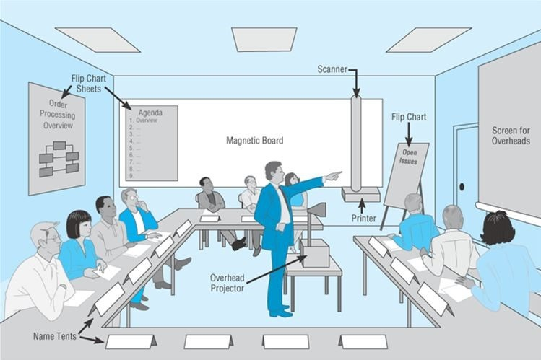

**Figure 5: Joint Application Design representation**

The lack of interaction from the Client or the Pseudo-client after giving the functional specifications is a significant problem that needs to be brought up. They anticipated that Consultancy B would design, test, and provide them with the ultimate answer.

The end effect of the aforementioned philosophy was that the client’s expectations were not met at all, and a large amount of time and money had already been expended. Both the client and the implementation team must alter their perspectives and ideologies in order to overcome this obstacle (consultancy B).

1. To provide input on the iterative version of the product, the customer and Consultant A (pseudo-client/stakeholder) communicate with the implementation team.

2. The waterfall method of software development cannot be the sole approach taken by the implementation team. They can use agile approaches, in this case, to prevent client rejection during the final stages.

**4.2. Agile Scrum Adaptation**

One methodology they can implement is the Agile Scrum Methodology which uses a time-boxed iterative approach that involves the client at important stages to gather feedback and improve the product.

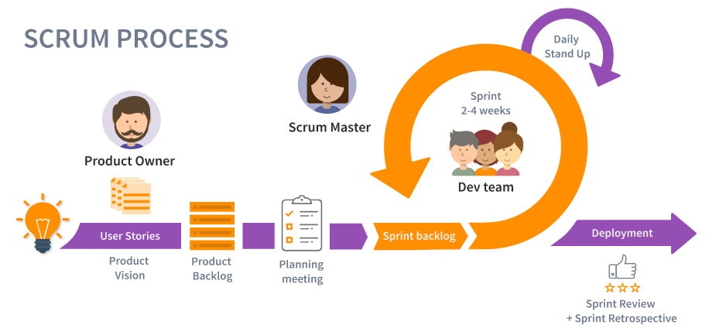

**Figure 6: Scrum Agile representation**

1. A scrum team can be mobilized with Client and Consultancy A occupying the product owner/ stakeholder roles which involves them creating a product backlog and prioritizing the items. This backlog is dynamic and flexible to additions based on new requirements, a scrum master to conduct/adhere to agile principles, and the developer team which implements the product.
2. The team works collaboratively to deliver a working product increment in a short period of time (usually 2-4 weeks) called a sprint. Each sprint consists of planning, execution, review, and retrospective phases.
3. The sprint review is a meeting at the end of each sprint where the team demonstrates the working product increment to stakeholders, collects feedback, and incorporates it into the product backlog. The sprint retrospective is a meeting where the team reflects on the previous sprint, identifies areas for improvement, and creates a plan for implementing those improvements in the next sprint. This approach can prevent situations faced by the implementation team where their product did not satisfy the client at one of the last stages of product development (acceptance testing).

## **5. Conclusion**

A perspective change is required for requirements gathering, involvement, and commitment from the client, increased collaboration, discussion, and communication channels and a shift in implementation methodology by consultancy B shifting to agile practices can greatly enhance their delivery and save the project.

## **6. References:**

1. “What is scrum?”, Atlassian.com , available at : [https://www.atlassian.com/agile/scrum](https://www.atlassian.com/agile/scrum%20) [accessed 8 March]
2. Anastasia Griva (2022), Requirements Gathering, Systems Development & Project Management, MS804, NUIG, unpublished
3. What Is Joint Application Design (JAD), available at : <https://students.warsidi.com/2018/07/joint-application-design-jad.html> [accessed 10 March]
4. 5 Reasons People Choose the Wrong Project Management Software (20/09/22), available at: <https://www.abtrac.com/blog/choosing-the-right-project-management-software> [accessed 10 March]
5. 11 Ways to Manage Project Conflict, available at: <https://www.liquidplanner.com/blog/11-ways-mange-project-conflict/> [accessed 10 march]
6. Understanding Agile Scrum in 10 minutes, available at: <https://www.tuleap.org/agile/agile-scrum-in-10-minutes> [accessed 10 March]
7. Top Reasons for ERP Implementation Failure (SEPTEMBER 15, 2021), available at: <https://freedomsoft.co.in/top-reasons-for-erp-implementation-failure/> [accessed 10 March]
8. An ERP Project: Business-led, Not IT-led!, available at: <https://lumeniaconsulting.com/insights/blogs/erp-a-business-project> [accessed 10 March]